How to Dispose of Mixed Chemical Wastes

- Step 1: Identify the materials you are working with. Non-reactive, neutral, non-hazardous materials can go into the general “sink” waste. Other materials such as those listed below should be segregated:
  - P-listed/acutely toxic
  - Acidic
  - Basic
  - Heavy metals
Figure 1: "Sink" general waste
  - Odorous
  - Insoluble solids
- Step 2: Generate a mixed waste label
  - Spell out all contents and indicate an estimated percentage of its contents.
  - Secure it to the bottle via the sticky part, tape or affix it to the neck of the bottle.
  - Keep small bottles around for special wastes
- Step 3: Store individual waste bottles in a secondary container.
  - Keep around individual waste bottles for reactions containing similar materials.
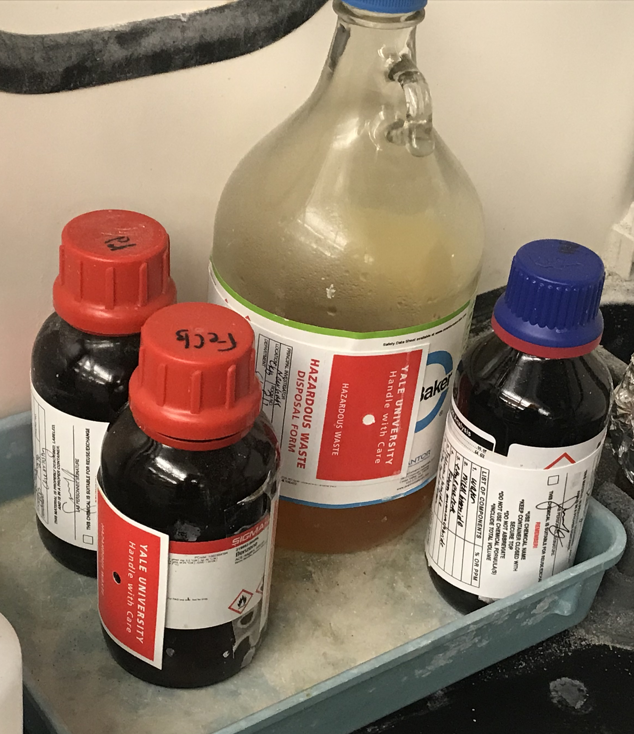
  - Dispose of in the satellite accumulation area (SAA) for pickup when finished or full.
Figure 2: Mixed waste label
Figure 3: Secondary container with individual mixed waste bottles

